Chocolate Doom Database Project

1. Introduction
The purpose of this project is to design a relational database capable of storing and analyzing telemetry data generated by a modified version of Chocolate Doom. The system records player movement, combat statistics, positions, and gameplay events during each game session.
In addition to gameplay data, the project also stores demographic information and UX survey responses to help researchers study player behavior, cooperation patterns, and user experience.

2. System Architecture
The project follows a simple layered architecture:
1. Data Source Layer: The game engine generates telemetry logs in TSV/CSV format.
2. Staging Layer: Raw data is first loaded into staging tables.
3. Core Database Layer The ETL process validates and transforms the data.
4. Analytics Layer: Cleaned data is inserted into the core relational schema.
5. Optimization Layer: SQL queries, views, and indexes support analytics and performance optimization.

3. ER Model Explanation
The ER model was designed to represent gameplay sessions, player activity, telemetry events, and UX survey data.
The main entity is TelemetryEvent, which stores player information for every game tic. Other important entities include User, Player, Game, Map, Sector, and UX-related tables.
Relationships between entities were normalized to reduce redundancy and maintain data integrity.
Entity-Relationship Diagram:
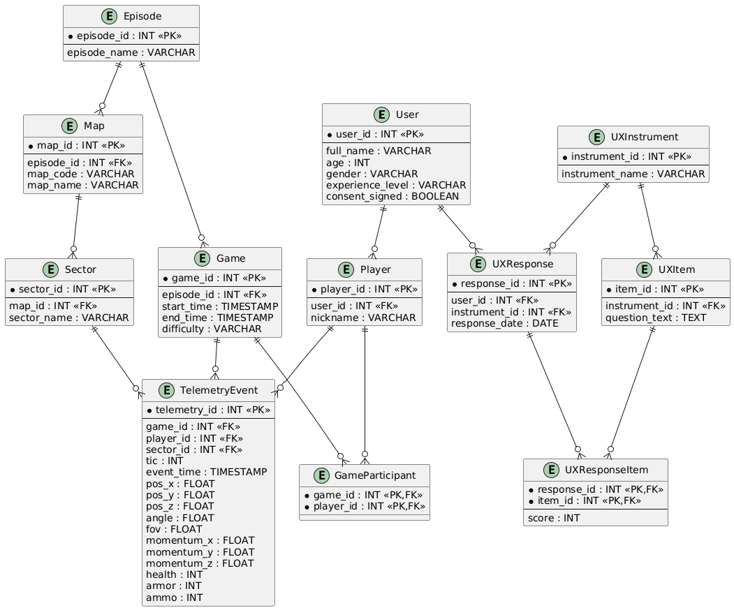

4. Data Dictionary
Entity | Description
User | Stores participant demographic and consent information.
Player | Represents in-game player identities and aliases.
Game | Stores information about gameplay sessions.
GameParticipant | Associates players with games.
TelemetryEvent | Stores per-tic telemetry data generated during gameplay.
Episode | Represents a game episode or campaign section.
Map | Represents playable maps within episodes.
Sector | Represents spatial sectors inside maps.
UXInstrument | Stores UX survey instrument metadata.
UXItem | Stores questions belonging to UX instruments.
UXResponse | Stores completed UX surveys.
UXResponseItem | Stores individual answers for survey questions.

